Reporting Template
Section 1 Basic Information
Note

1.a | Name of the leading Implementing Partner
1.b | The person approving this report | Name and email address | Role | Location
1.c | Contact information of the leading Implementing Partner | Postal address and website

1.d | Project Title
 | Total Project length (dd/mm/yyyy) | Start Date | End date | Duration in months
 | Period covered by this report
Location(s) of project
(region, country, sub national level 1, sub national level 2, community name)
 | Name(s) of all partners involved in project delivery

Section 2 Update on the Project Context

Guidance
This section should describe any changes you are seeing in the project area. This includes changes in the context, the needs, the groups you are working with and any changes to any risks that affect the project.

2.a | Describe any changes that have occurred in the overall context that you described in your proposal. How might these changes affect your project and have you taken any action as a result? [200 words]  (for example, political, economic, social, technological, environmental or legal changes)
2.b | Have you done a needs assessment or baseline survey since the start of your project? Yes / No. If yes, please describe your findings and describe any areas that are different from your project proposal. [200 words]
2.c | Describe any changes that have occurred within the groups of people with whom you are working, or in the level of their vulnerability. [150 words]  Note
2.d | With reference to the risk assessment table in your project proposal, please describe any changes to the risks you listed and any changes to the mitigation actions you have taken. If there are new risks, please describe them here. [250 words]  (Please include reference to fraud and corruption if any has occurred to date)

Section 3 Project Implementation and Impact

Guidance
In the table below, please outline how many project participants you have worked with up to the end of this reporting period, compared to the target from your proposal.

3.a Project Participants |  | Direct participants |  | Indirect participants
Reporting date |  | Target | Actual | Target | Actual
Female Under 18 years | people with disability
Female Under 18 years | people without disability
Male Under 18 years | people with disability
Male Under 18 years | people without disability
Female 18 to 59 years | people with disability
Female 18 to 59 years | people without disability
Male 18 to 59 years | people with disability
Male 18 to 59 years | people without disability
Female 60 years and over | people with disability
Female 60 years and over | people without disability
Male 60 years and over | people with disability
Male 60 years and over | people without disability
Totals
Total reached | direct + indirect participants =
Explanations Please use this section to add any relevant details of why the figures have changed

3.b Logframe
Please paste your logframe from your proposal in the table below, in the first two columns (grey boxes). Then update the final column with the progress you have made, reporting against your indicators.
Objectives | Indicators (SMART) | Progress to date  (insert date here)
Impact (Goal)
Outcome / Purpose
Outputs
Activities

3.c | i. Overall what is your assessment of how the project has progressed? - describe both the successes and challenges and how you have overcome them [up to 300 words]  Note
 | ii. Please explain any changes you plan to make to the logframe or annual plan as a result of your answer to question 3.c.i above.
3.d | i. Please report in the table below on progress to date against the planned long-term changes that you described in your proposal  Note
 | Planned Long Term changes | Progress to date
ii. Has your project helped to bring long term change by influencing the policies or practices of those in positions of power? [150 words]
Note
3.e | Are there changes that have occurred that have surprised you, or which were not planned? These may be positive or negative. Explain what happened and what you did in response.  (This could relate to any area, for example; safety, access and dignity of project participants; sexual exploitation and abuse; relationships with and between stakeholders; livelihoods; the local economy; unexpected community initiatives; the natural environment and others)

Section 4 Accountability to Communities

4.a | Has everyone in the community been able to participate in the project, particularly for people who often have difficulty in joining community activities, for example, people with disabilities, older people, children, women and minority ethnic groups? (Please explain how they have been involved and, if they haven’t been able to be involved, what the reasons for that have been) [150 words]
4.b | How have you shared information (for example budget plans, project plans, updates) with participants in a culturally appropriate way, especially with the most vulnerable and marginalised, and how do you know that this information has been understood? [150 words]  Note
4.c | i. Have you made any changes to the participant feedback systems that you described in your proposal? If yes, please give details. [100 words]
ii. What feedback have you received from participants about the project and how have they been involved in deciding how that feedback was given? Please include the quantity and types of feedback (you can summarise using a table or graph if you have one). [150 words]
Note
 | iii. How are you responding to the feedback you receive in a way that is timely, safe and appropriate? Please give some examples. [150 words]
 | iv. How has feedback led to changes to your project? Please give some examples. [200 words]
4.d | i. Have you received any complaints or concerns (including safeguarding concerns) about the behaviour of your staff, volunteers or partners who are implementing the project? Yes / No
 | ii. If yes, how many have you received and have you reported them to your funding partners?
iii. Without sharing confidential details, how have you responded to these concerns?
Note
4.e | How have you made sure that staff, volunteers and partners understand and practise your safeguarding policy and procedures and know how to report any concerns? [150 words]  Note

Section 5 Building Community Resilience and Sustainability

5.a | How is your project helping the community to be able to manage its own development after the end of the project? How will the community keep motivated after the end of the project? [150 words]  Note
5.b | Are there signs that the changes from the work of this project will continue after the end of the project? Please give details and include anything you can do to make sure the positive changes continue. [150 words]  Note
5.c | How have you strengthened the capacity of the local community through your project? [150 words]  Note
5.d | In your project, how have you included strengthening the capacities of those who may be marginalised such as people with a disability, older people or women? [150 words]
5.e | How is the project reducing vulnerabilities (the possibility of being harmed) within the community? [150 words]  Note
5.f | In what ways has the project helped build community resilience (the ability to deal with future problems)? [200 words]  Note

Section 6 Programme Management and Effectiveness

Guidance
This section provides the opportunity to show what you are learning as you monitor the project, how your staff are growing in capacity, how you are coordinating your work with others and how you are making sure that the quality of the project is maintained and that you are following the relevant codes of practice.

6.a | What experience have you gained, what lessons have you learned and how will you share these within your organisation, with peers, with project participants and others? [200 words]  Note
6.b | How are you using what you have learned to make changes to the way that you run your project? [200 words]  Note
6.c | How have community members and project participants been involved in the monitoring and evaluation of the project? [150 words]

6.d | Have there been any changes to your staff or management structure during the reporting period that are significant for the project? If so, please explain. [150 words]
6.e | What capacity building and training activities have you done with your own staff? [150 words] (For example, learning visits to other projects, training in skills, good practice, security and staff welfare)

6.f | How have you coordinated your work with other organisations in the area, with local government authorities and other stakeholders? [150 words]
6.g | What have been the successes and challenges with this coordination? [150 words]

6.h | Please describe, for each main sector of activity, what challenges you have had in following good practice and technical standards. Please refer to the challenges you described in your project proposal and any other new challenges you have had. [200 words]  (please refer to CHS, Sphere and other standards relevant to your project)
6.i | How have you made sure that your project uses resources efficiently, minimises waste and does not cause harm to the environment? [150 words]
6.j | How has the project contributed to changes in the position and respect for women and girls in their households and communities? What problems remain for equality for women in the project area? [150 words]  Note
6.k | How has your project been able to remove any barriers that stop vulnerable groups participating fully in this project and in society? [200 words]  (barriers may be attitudes; laws/policies and procedures that exclude certain groups; physical access and access to information)  Note

Section 7 Local Faith Community

7.a | What role has the local faith community played in the project? [200 words]
7.b | How has the project supported the local faith community in their work in the local area? [150 words]

Section 8 Case Studies and Stories of Change
Please provide at least one (but preferably three) story or case study from your project that has occurred during this reporting period. Please include photographs and videos as these really help to promote the work you are doing with supporters.
Note

N.B. These stories may be shared with external audiences. Therefore, consent should be obtained. Please confirm below whether signed consent has been given and, if not, give details of any restrictions that apply.

The purpose of the story is to show the type of change that is happening as a result of your project work. For example, you could show the difference in the situation of a project participant before the project started compared with what they are experiencing now as part of the project. Please use the table below and check with your funding partner(s) if they have a particular template they would like you to follow.

What are the participant’s details? (name or fictitious name, age, family details, location and occupation or position in the community)
Describe the participant's needs before the project. What was the problem they faced and why did they face it?
Describe clearly what the project did to provide a solution to the participant’s problem.
How has the participant’s life changed as a result of the project? What are their hopes for the future?
Please provide any quotes and images you have to accompany the story.

Section 9 Financial Report

Please complete the separate excel spreadsheet entitled Micah Global Financial Report Template or use your own format / extract from the accounts comparing budget to realisation.

Guidance

This template can be used for all reports.

Questions have a suggested length for the answer in words, for example [150 words]. This is for guidance only. Different projects will have more or less to say depending on the individual circumstances.

Guidance notes are given throughout the form. Wherever the word Note appears, this means that there are guidance notes that can be found in Annex C. Further examples and information can be found in the appendix.
For projects lasting 6 months or less* | please answer only the questions in black text
For projects lasting more than 6 months | please answer all questions, both the questions in black and pink text
*It may be sufficient for some smaller projects that last longer than 6 months to fill out the shorter version of the template; please discuss with your funding partner.

Guidance - Glossary of Terms
Micah members come from every region of the world, using many languages and from diverse backgrounds. Micah members are aid organisations, mission organisations, local congregations, inspired individuals and activists. It is therefore important that we describe what specific terms mean in the relief, rehabilitation, development, advocacy, reconciliation and creation care sectors.

Term | Definition
Baseline | A record of what the situation is like before a project or programme starts, so progress can later be measured and compared against this record.
Child | A person under the age of 18 years
Concept note | A brief summary of an idea for a project.
Direct Project Participant (Beneficiary) | An individual, group or organisation, that has been directly involved in a project activity, has received a direct service through the project or who has worked in the project.
Disability | A physical or mental issue that, together with the person’s living environment, has a significant and long-term negative effect on the person’s ability to do normal daily activities
Emergency Response | A response to a new emergency such as a natural disaster or sudden displacement of people (rapid onset). Or a response to a period of greater vulnerability during a long-term emergency or protracted crisis (may be slow onset).
Gift in Kind | An item or service (rather than money) that is given for use in the project.
Goal | The long-term result or wider objective that a project contributes towards (even if the project/programme by itself cannot achieve it).
Impact | (i) Higher level long term sustainable changes usually not within the control of any specific project. (ii) How a project alters the state of the world. (iii) Positive and negative, primary and secondary long-term effects produced by an intervention, (directly or indirectly, intended or unintended).
Indicators | Quantitative or qualitative factor or variable that provides a simple and reliable way to measure achievement, to reflect the change connected to a project, or to help assess the performance of a project.
Indirect Project Participant (Beneficiary) | An individual, group or organisation who has indirectly benefited from a project activity, for example, in a child nutrition project, other members of the community will indirectly benefit as well as the children themselves benefiting directly.
Logical framework (logframe) | A table used to explain and summarise what a project will do, including the logic of how the activities, outputs, outcomes and goal are related, the indicators and means of verification to measure the objectives and key assumptions in the design.
Market Assessment | The process of collecting market-related data to understand the key features and characteristics of a market system or the impact a disaster could have on the market system.
Needs Assessment | The process of identifying and understanding a community’s/people’s needs
Objective | A general word used for a desired change.
Outcome | i. A change that occurred because of your project. It is measurable and time limited, but it might take time to see the full effect. ii. The likely or achieved short-term and medium-term effect of the project outputs.
Output | (i) The products, both seen and unseen, that result from project activities. (ii) The products, goods and services which result from a project. May also include changes which contribute to the achievement of outcomes.
Programme | A set of projects that work together to meet specific objectives, to an agreed standard, within a certain time and cost.
Project | A self-contained set of activities to achieve defined objectives.
Project Participant (Beneficiary) | An individual, group or organisation, whether targeted or not, that benefits directly or indirectly from a project.
Qualitative | A measurement of the quality of something
Quantitative | A measurement of the quantity of something
Rapid Onset Emergency | An emergency that happens suddenly (e.g. earthquake)
Rapid Response | Three months or less from the start point of the emergency
Stakeholder | An individual, group or organisation with an interest or concern that relates to the project, or who may be affected or experience change as a result of the project.
Slow Onset Emergency | An emergency that develops over a period of time (e.g. famine)
Vulnerable Adult (Adult at Risk) | A person who is 18 years of age or over who is or may be unable to take care of him/herself, or unable to protect him/herself against significant harm or serious exploitation

Guidance Notes

Ref. | Note
1 | The information you give in this section should relate directly to the information that you gave in the same section of your proposal form.
2.c | These should be changes compared to the situation that you described in your proposal form.
3.c | Please share about your challenges; these are often when we have the opportunity to learn the most.
3.d | i. This is your chance to explain in more detail how things are progressing towards the changes you had planned in your logframe.  ii. This might be directly as the result of a project activity or more because of secondary or tertiary impacts of your project.
4.b | As well as sharing the information and updates about the project with the participants you need to know that they have understood what has been shared. How have you checked that they have understood?
4.c.ii | You do not need to list every detail of the feedback but rather give a summary of the main issues. Please also include the details of how often and how often feedback was given.
4.d | Confidential information such as the identity of people or their personal details should not be shared. General details can be shared that give an idea of the issue.
4.e | This might be through training, role play, learning lessons from project events etc.
5.a | Are there individuals or groups in the community who will take responsibility in the future for making sure that the community keeps trying to improve and that all its members are properly involved and cared for?
5.b | This question is about the positive changes that you think might continue after your project finishes (rather than asking about who will take responsibility in the previous question).
5.c | What is the community (or participants) able to do for itself that it wasn’t able to do before your project started?
5.e | This could be the direct result of the project (e.g. building a water storage tank in a location that will not be affected by natural disaster) or an indirect one (e.g. Better access to markets that means people have money to improve their homes).
5.f | e.g. better health, more resilient crops, savings, disaster plans, better relationships with authorities, effective community groups etc.
6.a | These could have been through successes or challenges in your project. It is important to plan to share your learning with others to help improvement in the future.
6.b | For example, you might have realised that a project activity is not having the outcome that you had planned and so you have changed it.
6.j | This could have happened many different ways, e.g. women’s groups that are respected by the community, employment for women, education for girls, women involved in decision making, better health access etc.
6.k | For example, a new health clinic that employed women for the first time in a community removed the barrier that prevented women from working in that community.
8 | Videos taken on a mobile phone, as well as well as more professional videos can be used. (DH: Add more guidance here, ref case study and story templates from Tearfund.)
10 | It might be necessary for you to complete your new work plan before you fill in this report. Please discuss timescales with your funding partners
D.7 | For example, a new health clinic that employed women for the first time in a community removed the barrier that prevented women from working in that community.

The Core Humanitarian Standard on Quality and Accountability

The Nine Commitments
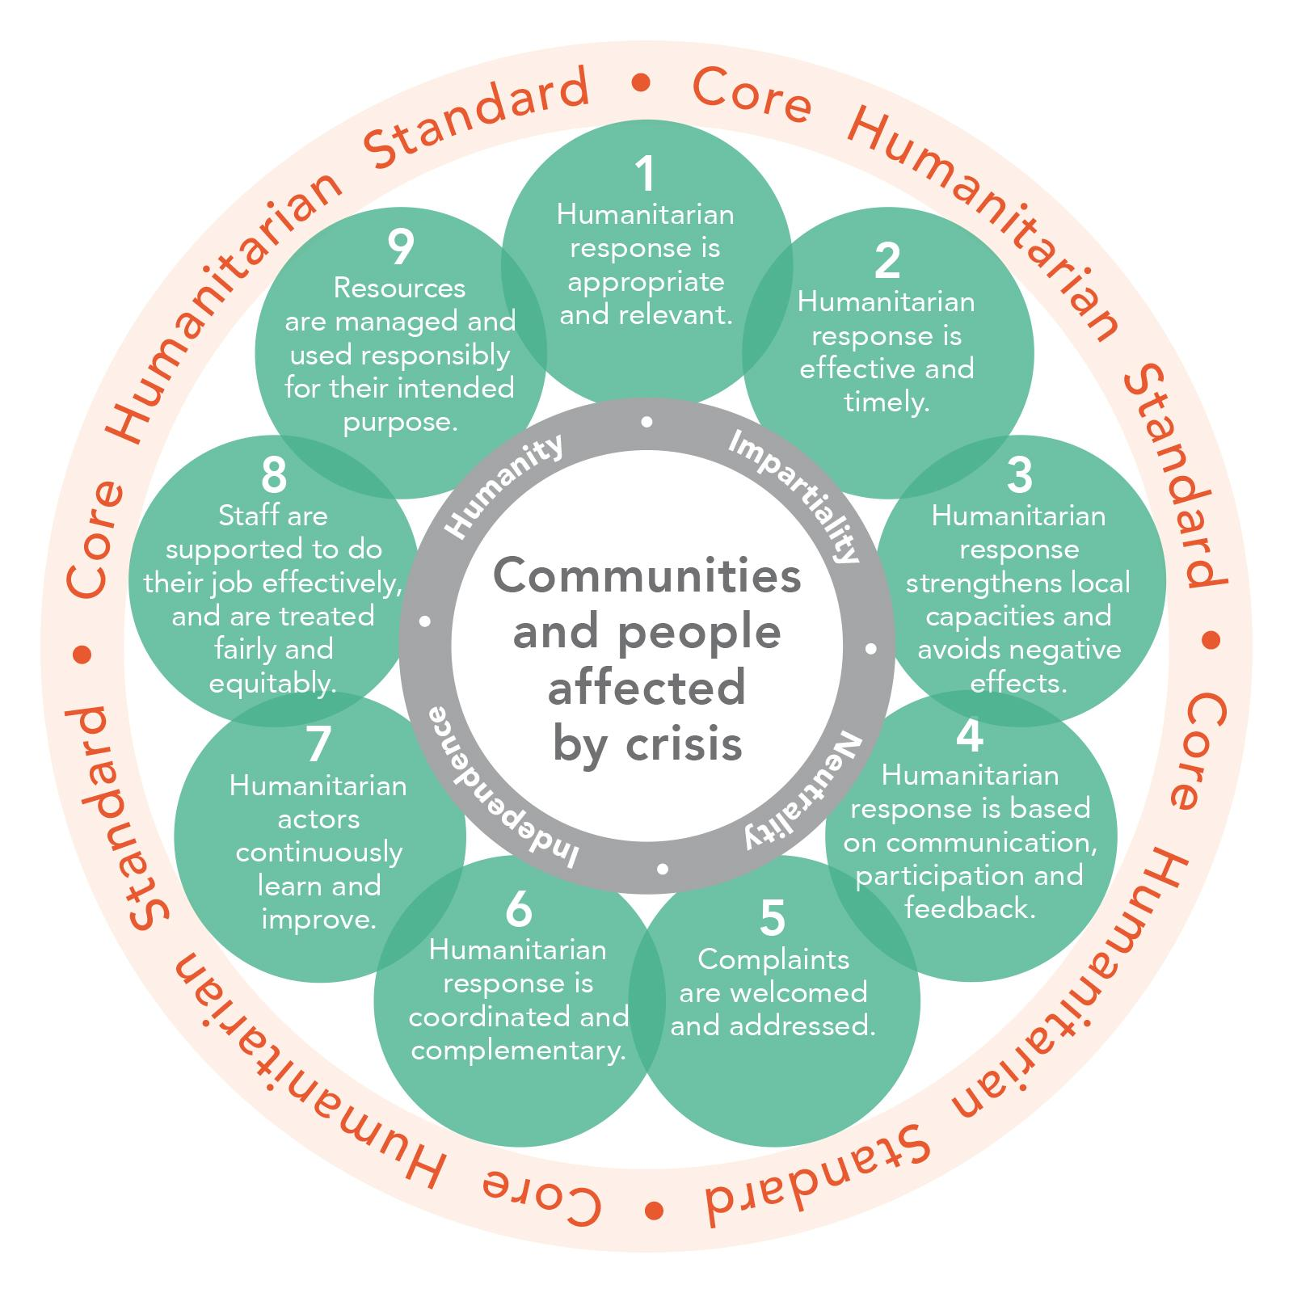

The Core Humanitarian Standard on Quality and Accountability - the Nine Commitments are provided in Annex A

